### Report of ted video website

### The reason why we want to create such a website

TED is a video website. The videos on it cover all aspects, which can expand viewers horizon. Besides, the speeches are almost given by native speakers. They’re good listening materials.

However, it’s an oversea website. That means it takes a lot of time to wait for it loading and it’s unstable. Besides, it has ads.

So we think why not collect the information of the videos and create our own website?

### The group members and our respective responsibility

戴语彤：responsible for crawling

杨冬宁：searching engine

申艾瑶：visualization

俞快，葛媛：website

### The implementation

## 1.crawling

##### Design and Prediction

As the foundation of the whole project of web development, information requested to be obtained from the original web is closely related to what we plan to demonstrate in our website. The titles and covers of the videos are essential. The brief description of the video, the post time and duration, and introduction of the speaker can provide more information about the video for visitors. Tags and views can be useful in making charts and ranking lists. Moreover, to provide access to the original video for visitors, the link of the video is needed.

After we made it clear that what we want, we could get down to the crawling work.

Once we get all the information, we just need to load the data into database. Instead of sharing one database, each of us got a copy of the information file and the Python program to load the data into our own local database respectively. The program was encapsulated, so that there was no need for other team members to learn about the database operations, which made our division of work very clear.

**Process**

We first visited the home page of the original TED website, and studied the HTML statements carefully. After we thoroughly understood the structure of the website, and found out where we could find the information we needed, we wrote the original version of the crawler program. We encountered some unexpected problem in practice. So we modified the program step by step, and finally it worked out.

In fact we made a small mistake at first. We forgot to obtain the information about the duration of the videos. The cost of time is unaffordable if we crawled all the information again. However, in the attempt to obtain the duration separately, we found that the videos in the original websites were slightly different from before. Two videos were added, while three were missing. Finally we took the intersection of the results of the two crawlers.

### 2.searching engine

**Design and Prediction**

In this part, our aim is to implement a Multi-term and Multi-field Supporting Search Engine. By saying ‘multi-term’, we mean it supports searching for more than one keyword at a time. By saying ‘multi-field’, we mean it supports searching two or more fields. Here’s an example.

If the user want to search a video whose title contains ‘Bird’, he can enter the word ‘bird’ in TITLE field. If the user has more information, he can reduce the result by adding more conditions, like the post time of the video, or the name of the speaker(s).

In addition, this engine is predicted to provide ranging and sorting function. In other words, it should enable users to get the items in a specified range and sorted by a specified method.

We used Elasticsearch and coded it by python to implement this. Elasticsearch is the distributed search and analytics engine at the heart of the Elastic Stack. Elasticsearch provides near real-time search and analytics for all types of data. Whether you have structured or unstructured text, numerical data, or geospatial data, Elasticsearch can efficiently store and index it in a way that supports fast searches.

**Implementation**

**Data Structure**

This was the data stored in our database. What we need is to create an index with appropriate mappings and analyzers and then add the documents. Six fields are identified for searching – Title, details, tags, speaker’s name, speaker’s profession, speaker’s introduction.

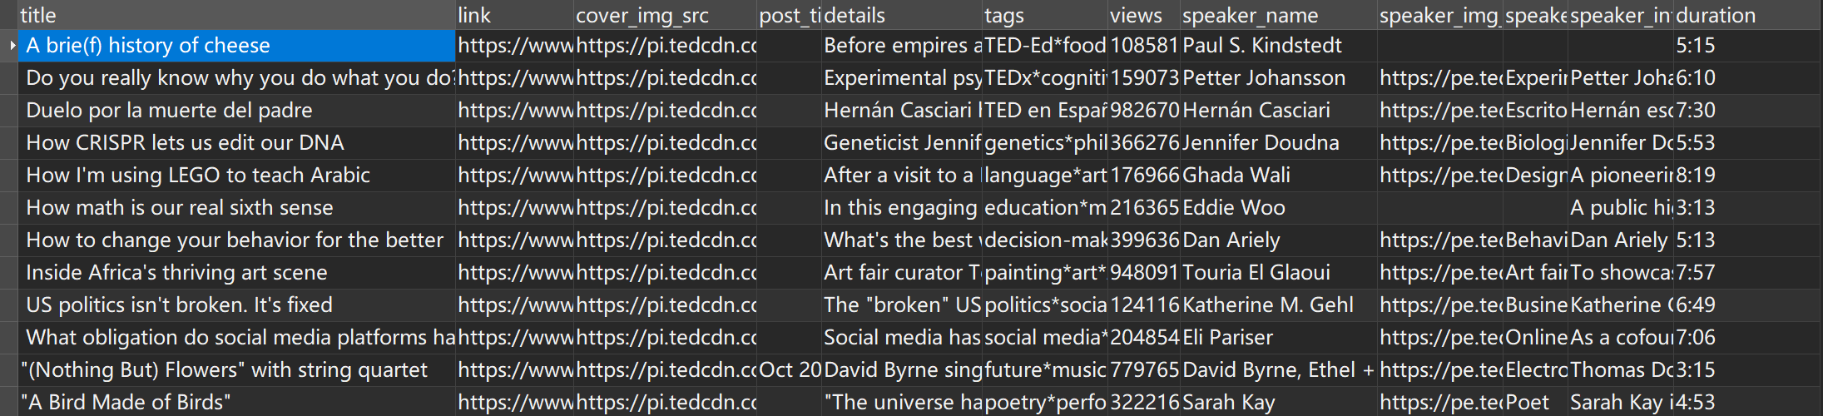

**Mappings**

|  |  |  |  |  |  |  |  |
| --- | --- | --- | --- | --- | --- | --- | --- |
| **field** | title | link | cover_img_src | post_time | details | tags | views |
| **type** | text | text | text | month and year (integer) | text | keyword | long |
| **queryable** | T | F | F | T | T | T | F |
| **field** | speaker_name | speaker_img_src | speaker_position (profession) | speaker_intro | duration |  |  |
| **type** | text | text | text | text | text |  |  |
| **queryable** | T | F | T | T | T |  |  |

We added an Index parameter in mappings, so as to define the field as queryable or not. The index option controls whether field values are indexed. It accepts true or false and defaults to true. Fields that are not indexed are not queryable. For example,

"speaker_img_src":{ "type": "text", "index": "false" }

means "speaker_img_src" is not queryable.

We processed the data in “post_time” field by transforming strings to integers. For instance, when we get ‘Oct 2010’ from the table, we store it as a dictionary {“month”: 10, “year”: 2010}, both values of which are integers.

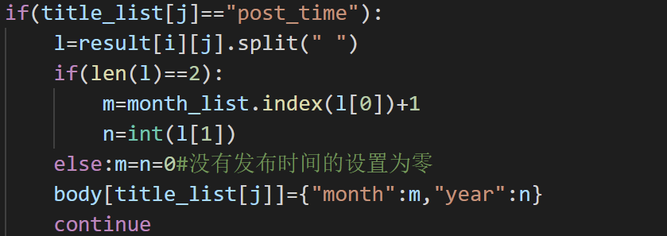

We set information in “tags” as Keyword type for convenience of exact-values searching. In preprocessing, we split the strings into separated single words and stored them in a list.



**Analyzer**

Since there’s no need for complex analysis for the texts, we just used standard tokenizer and the Lowercase filter.

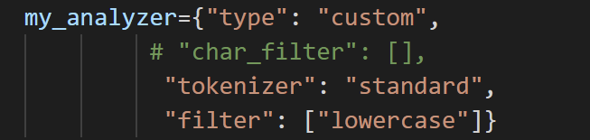

**Connection and Creation**

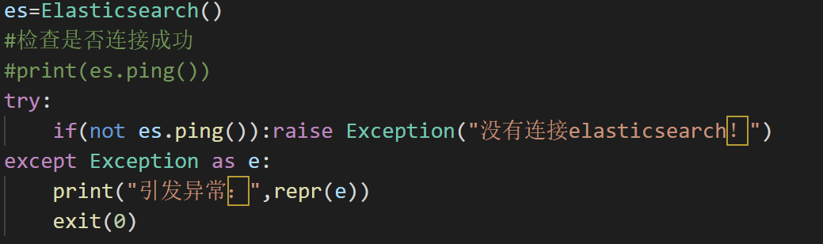

If the user doesn’t open the Elasticsearch service, the program will exit.

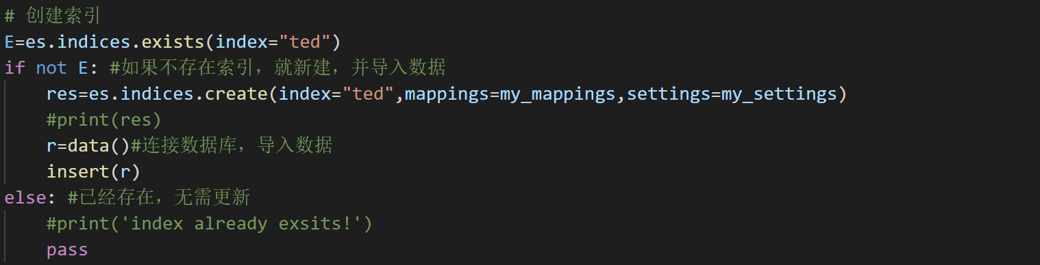

**Adding Documents**

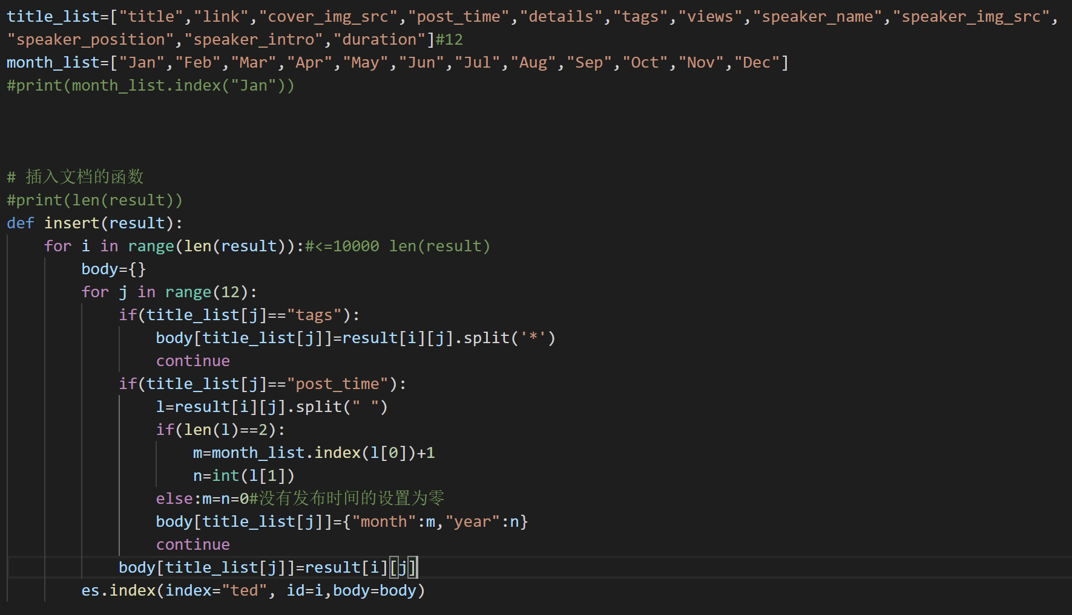

**Query to a Document**

To examine if we have already added these documents below the index.



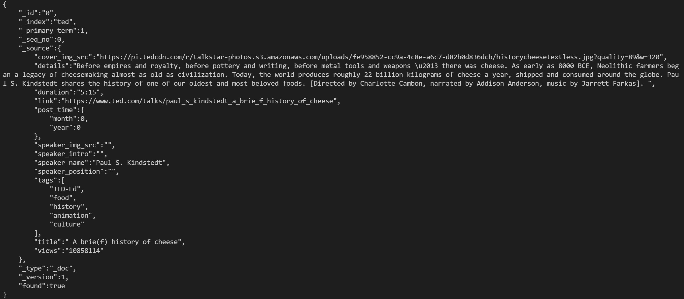

**Searching**

Input

Three parameters are needed from users, namely the keywords, searching range and sorting method. In our code, these were stored as three dictionaries correspondingly. Look at the example.

#e.g.1

keyword={ "title": "Bird", "details": "universe" , "tags": "poetry performance painting" , "speaker_name": "sarah", "speaker_position": "poet", "speaker_intro": "poet is" }

search_sort={ "views":0, "post_time":0}

search_range={}

“Keyword” has at most six keys. If any of the fields doesn’t get any input, the value can be set as “0”, or delete the key from this dict. For example, if keyword={ "title": “0”, "details": k2}, then it only search details field for k2.

search_range={“year”:[int a, int b](, “month”:[int c, int d])}

Posted time ranging from year a to year b, month a to month b. (a<=year<=b, c<=month<=d) search_range={} is also valid.

search_sort={ “views”:state1 , “post_time”:state2} has no defaulted item.

state1(state 2) being 0 means no ranking, while being 1 means sorting in an ascending order, and being 2 means sorting in a descending order. If state1=state2=0, then sort it by the relevance score. If none of them are zero, views field has a priority. Here are more examples.

#e.g.2

keyword={}

search_sort={ "views":1, "post_time":2}

search_range={"year":[2010, 2010]}

#e.g.3

keyword={}

search_sort={ "views":0, "post_time":0}

search_range={"year":[2010, 2010],"month":[10,10]}

**function**

In this part, we used Boolean Query. It is a query that matches documents matching boolean combinations of other queries. It is built using one or more boolean clauses, each clause with a typed occurrence. The occurrence types are:

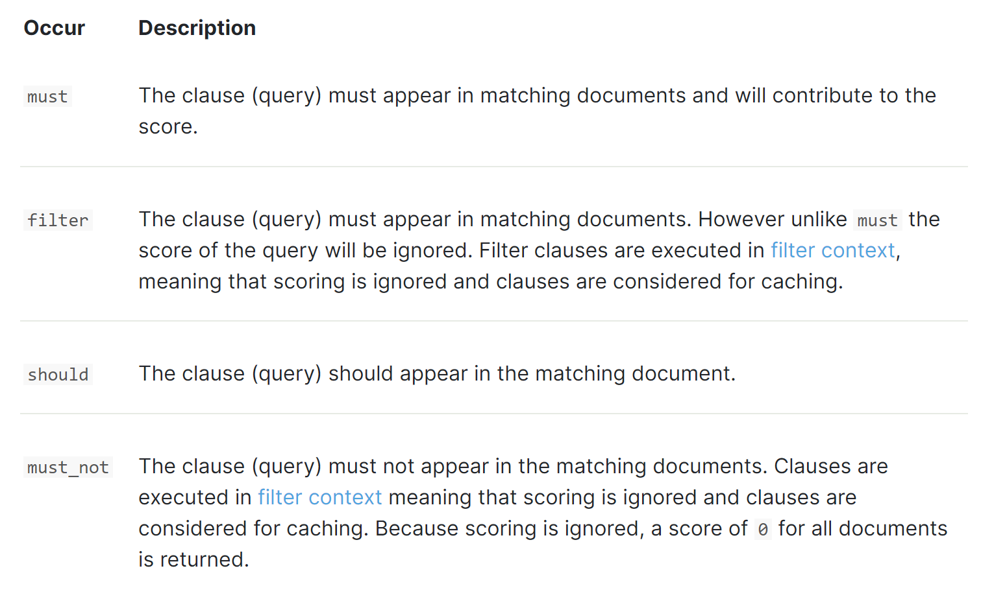

The bool query takes a more-matches-is-better approach, so the score from each matching must or should clause will be added together to provide the final _score for each document.

The function below returns the processed boolean query for each search.

def search(keyword:dict,search_range={},search_sort={ "views":0 ,"post_time":0} ):

    query=[]

    search_aim=[]

    for key in keyword.keys():

        if(keyword[key]!="0"):

            if(key=="tags"):query.append({"terms":{"tags":keyword[key].split(' ')}})

            else:

                query.append({"match":{key:keyword[key]}})

            search_aim.append(key)

    sort=[]

    if(search_sort["views"]!=0):

        sort.append(view_sort[search_sort["views"]-1])

    if(search_sort["post_time"]!=0):

        sort.append(time_sort[search_sort["post_time"]-1])

    sort.append(default_sort)

    #print(sort)

    ymin=0

    ymax=9999

    mmin=0

    mmax=12

    if(search_range.get("year",-1)!=-1):

        ymin,ymax=search_range["year"][0],search_range["year"][1]

        if(search_range.get("month",-1)!=-1):mmin,mmax=search_range["month"][0],search_range["month"][1]

    range=[{"range":{"post_time.year":{"gte":ymin,"lte":ymax}}},{"range":{"post_time.month":{"gte":mmin,"lte":mmax}}}]

    #高亮搜索

    highlight={

        "fields":{}

    }

    for item in search_aim:

        highlight["fields"][item]={}

    bquery={"bool":{"must":query,"filter":range}}

    #print(bquery)

    return bquery,sort,highlight

If we input this,

keyword={"title": "Bird", "details": "universe"}

search_sort={ "views":0, "post_time":0}

search_range={"year":[2010, 2010],"month":[10,10]}

then, bquery=



**function usage:**

query,sort,highlight=search(keyword,search_range,search_sort)

search_result=es.search(index="ted",query=query,sort=sort,highlight=highlight,size=20,from_=20*j)

All the results are stored in search_result.

###### Interfaces with Other Modules

For convenience of external users, we wrapped the function in a function wrapper outerSearch.

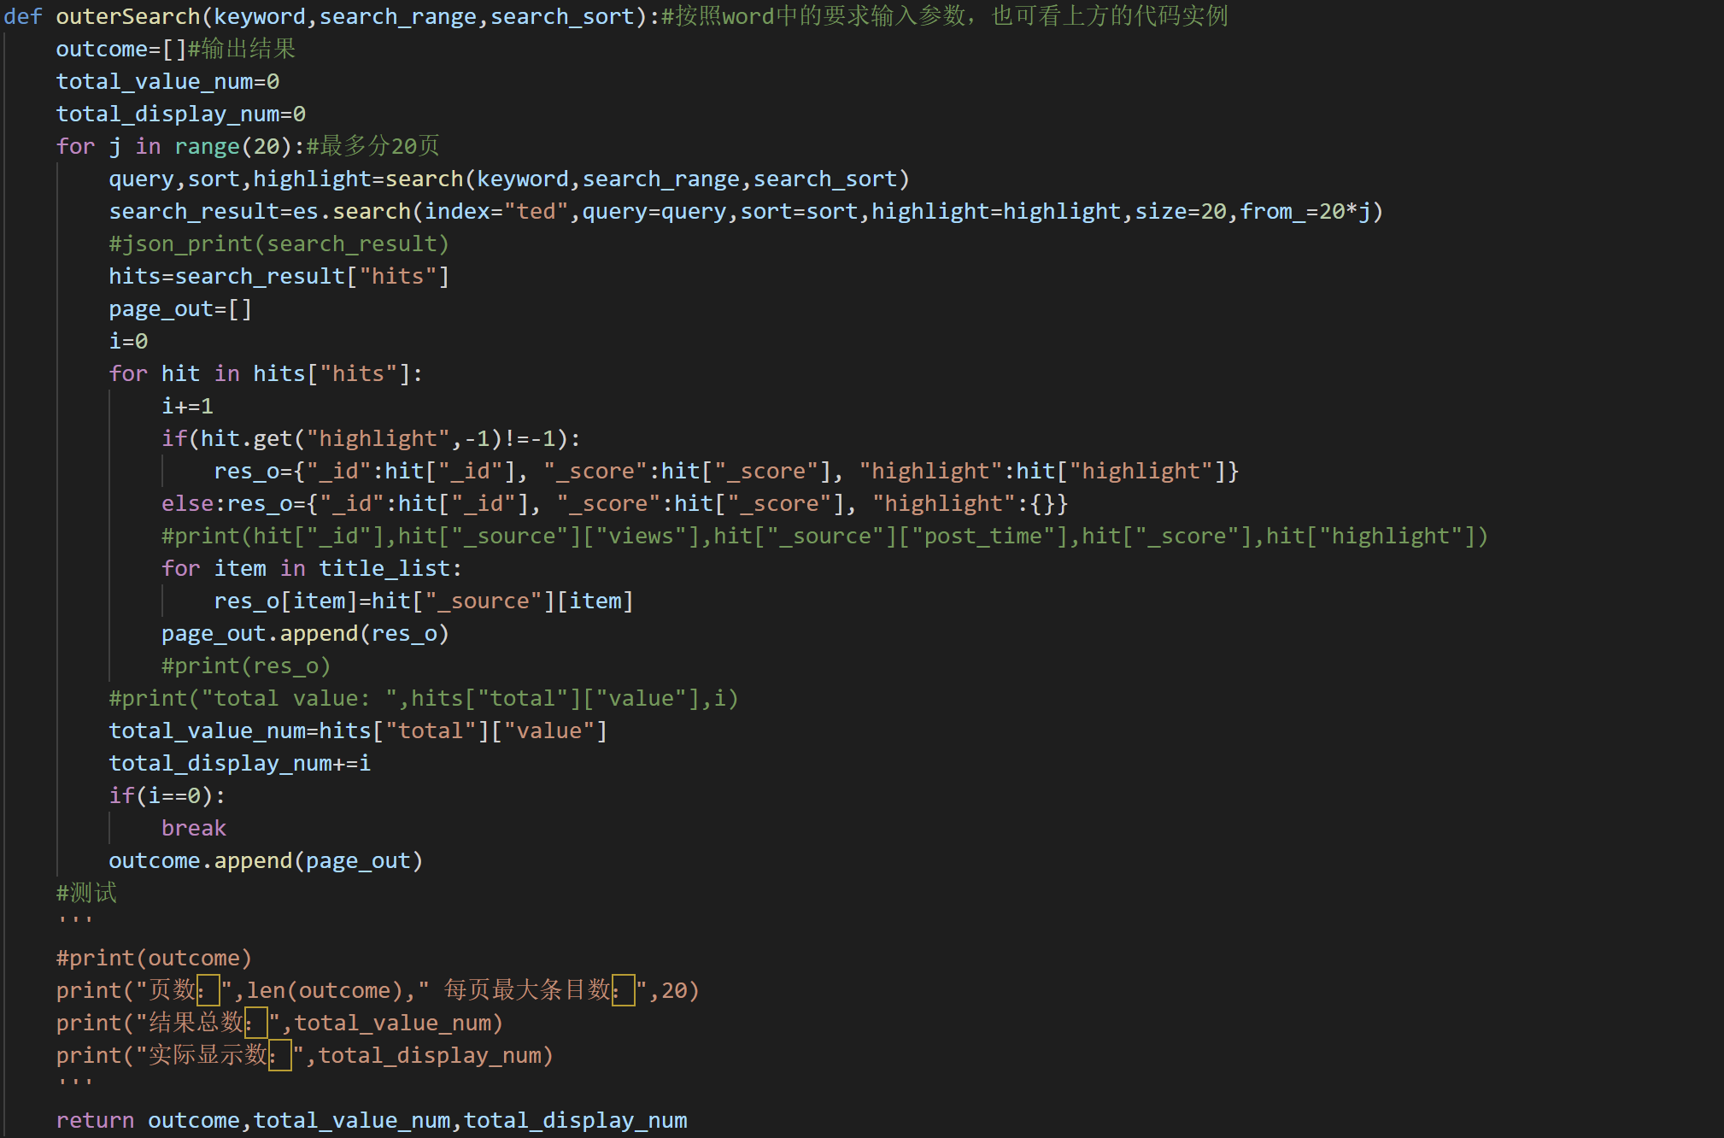

Outcome information:

outcome[page][index]={ "_id", "_score", "highlight", "title", "link", "cover_img_src", "post_time", "details", "tags", "views", "speaker_name", "speaker_img_src", "speaker_position", "speaker_intro"}

Users can simply import the file as a python module and then recall this function to get the results.

###### Documents

To make it easy to use, especially to our group members who are in charge of website development, we wrote a “readme” document and shared it with our initial code. We updated the document simultaneously as we modified the code. Here is the outline of the latest version of the document.

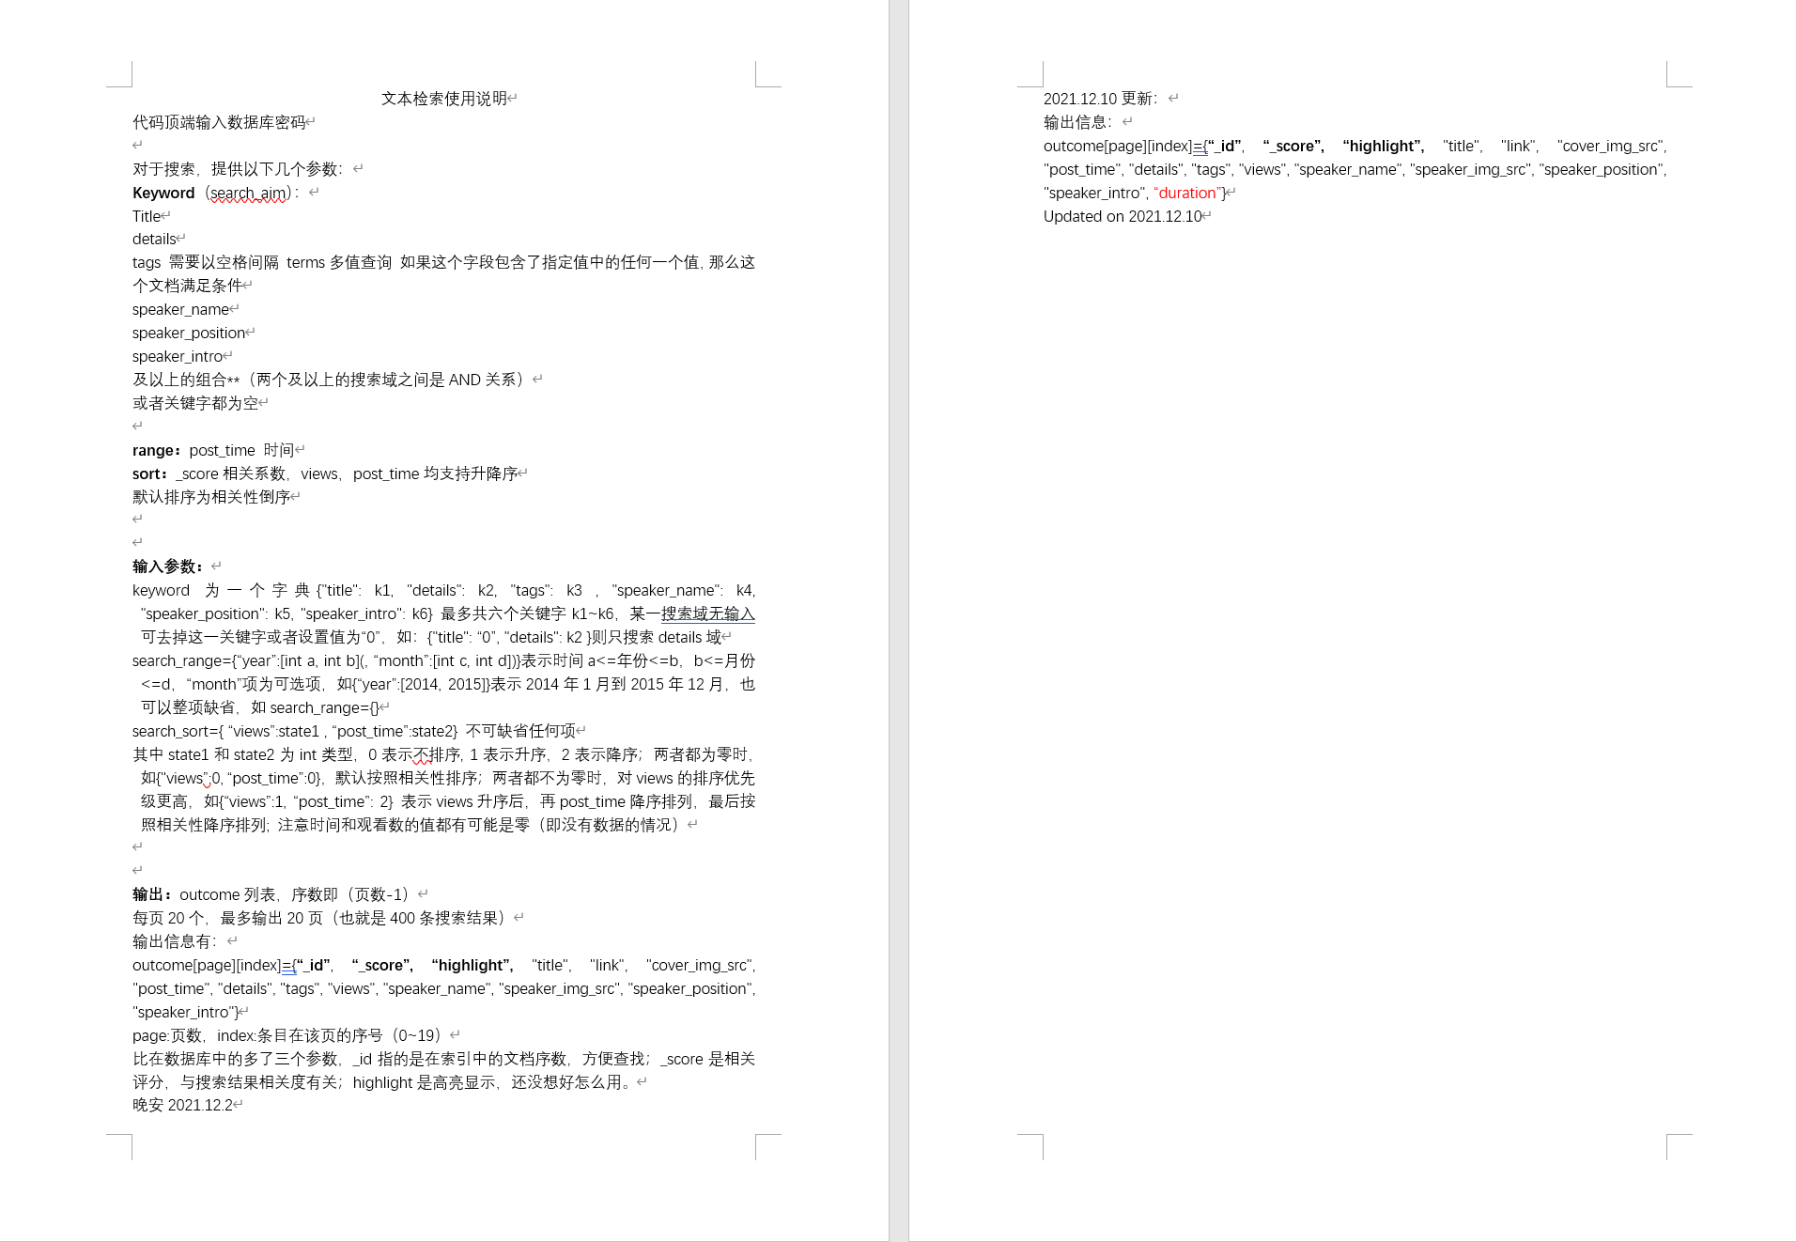

###### Test and Operation

Operation Instance

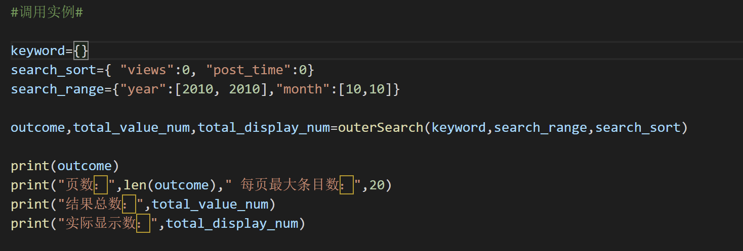

Outcome

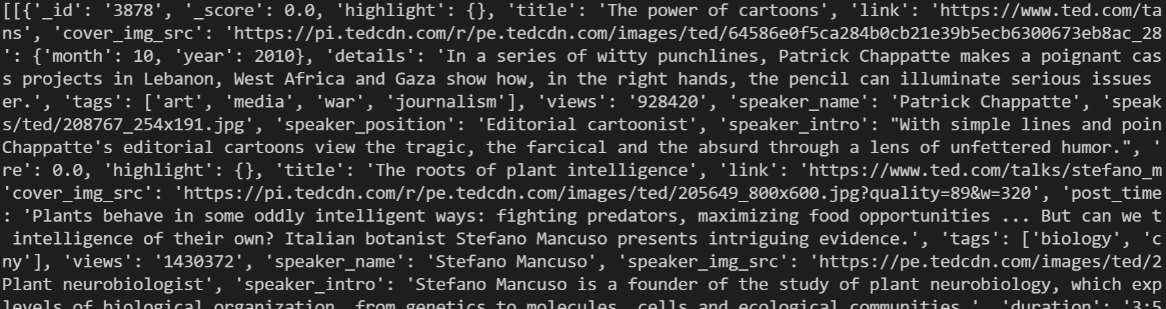



## 3.visualization

**Design and Prediction**

1. An Echarts bar chart showing the top 10 most viewed videos in the TED videos and jumping to the corresponding video playback screen when the bar is clicked.

2. An Echarts bar chart showing the top 10 topics in the TED video in terms of number of appearances.

3. A Gephi chart with all topics as nodes and the total number of times the topic appears as the value of the node. If two topics appear in the same video, the two corresponding nodes are considered to have edges between them, and the weight of the edge is added by one for each occurrence. Exhibit the strength of the relationships between the topics and the different communities to which they belong.

4. An Echarts node-relationship graph with all topics as nodes, showing all edges with a weight of not less than 4 in the graph, and showing all nodes related to a node when the mouse is placed over it.

**Implementation**

1. How to realize jumping to the corresponding play screen after clicking on a bar?

Add the function mycharts.on() to the echarts_views.html where the top 10 videos graph are placed, and add a property links in the views.json file where the top 10 links are placed. The code is as follows.

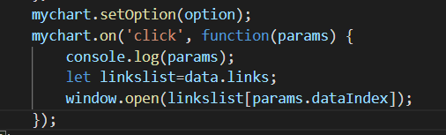

2. How to adjust the filter information so that the node information of the Gephi diagram does not interfere with each other; how to partition; How to reflect the strength of the relationship between the nodes?

Methods to prevent interferences:

Use the Force Atlas layout in Gephi, adjust the repulsion strength to 6000, check "Adjust by size", filter by the degree of the range, and filter out nodes with a degree below 30 to prevent nodes from overlapping due to too dense; use the value of the node as a measure of the relative size of the nodes, the minimum In the preview settings, choose Show node labels and Shorten labels to prevent labels from covering each other; adjust the thickness of the edges to 0.1 and the transparency to 200.0, and choose Bend to prevent node information from being obscured due to too dense a distribution of edges or too heavy an edge color.

Partitioning.

Calculate modularity in statistics, use Modularity Class when coloring the nodes, the software will automatically give the colors and partitions, you can adjust the colors of the blocks to prevent color clashes.

Method to show relationship strength:

The color is set to mixed in the column of edges in the preview settings, the color of the displayed edge is a transition of the color of the two nodes it is connected to, showing the distance between the nodes.

3. How to obtain the weights of the edges?

Method of obtaining edge weight:

New sorted_ data.py file, using Python method to obtain database data for filtering.

4. How to import the data of nodes and edges into the Echarts node-relationship graph, Specifically, how to obtain the coordinate information of the nodes (since they do not have coordinate properties); how to control the size of the nodes so that they do not cover each other; how to set the parameters so that the edges are not so dense that they cover the nodes?

Data importation of nodes and edges:

Node attributes include: x, y, ID, name, symbolSize, itemStyle (color); edges attributes include: sourceID, targetID, weight.

Node has no coordinate attribute. In order to give node coordinate attribute, two groups of random numbers obeying normal distribution are generated by library function according to mathematical law, which are used as the horizontal and vertical coordinates of node respectively;

The node id is the sequence number arranged in descending order according to the occurrence times;

The name of the node is the name of the topic;

The symbolSize of the node is the value of the node;

The color attribute of the itemStyle of the node is set according to the colorList loop;

The sourceIF and targetID of the edge are the ID of the node;

The weight of the edge is the weight of the edge itself;

In the graph, the nodes are displayed on the canvas according to the given horizontal and vertical coordinates; the label content of the node is the name of the node; the size of the node is the symbolSize of the node;

Parameter setting:

The symbolSize of a node is not equal to its value, but is equal to the unified division of the value by 15, which can effectively prevent coincidence caused by too large nodes;

The parameter of normal distribution coordinates is expected to be 0 and the variance is 1000000. This group of parameters can effectively disperse nodes, and the number of coordinates is 348 nodes;

Set the label position of the node to the right to prevent the node labels from overlapping.

Filter the input data and eliminate the edges with weight less than 4.

## 4.website

**Design and Prediction**

In this part, we design nine pages to fully make use of the search engine we’ve already built and the data we’ve crawled.

The first page is Frontpage, we start from here to have a brief view of the functions we are going to realize. The background of the Frontpage is a picture of ted talk, below the page are three buttons: Search(navigate to the search page)、Rank(navigate to rank page) and More(navigate to the visualization result)

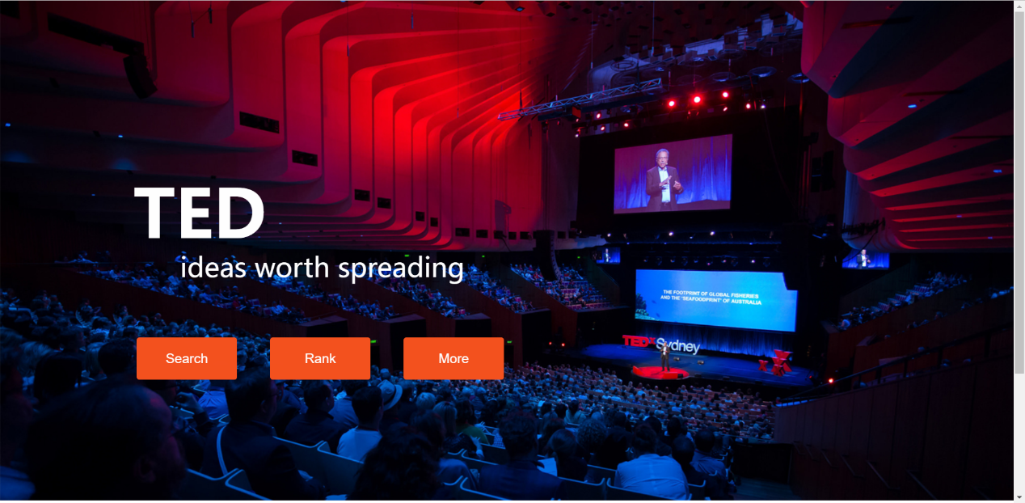

When we enter the search page, we can have several search boxes to do multisearch just as many papers search website designed. After users enter the content we hope to find, users press the search button.

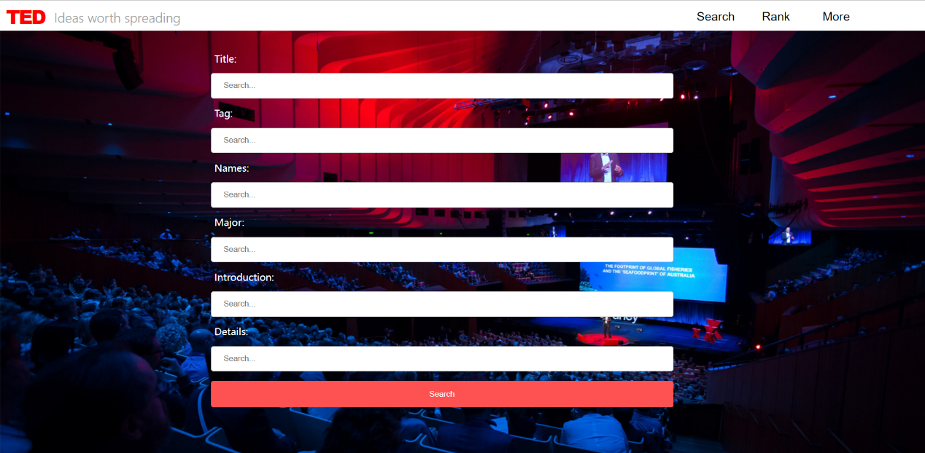

Then users come to the Results page, in this page, we will exhibit 20 results at one page at most, more results can be exhibited after page turning. The results are shown in the way of picture with hyperlink, and if users move the mouse to the result picture, the details of the video will be shown. If the users click the picture, they will enter the website of the original TED website to watch the video.

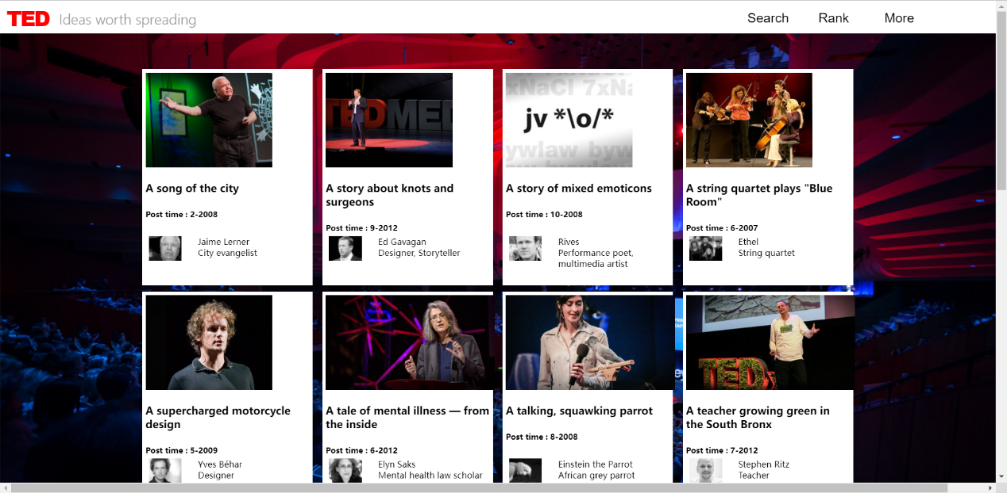

In the page of Rank, we choose the top5 most viewed ted talks to recommend to our users, with view data shown and hyperlink.

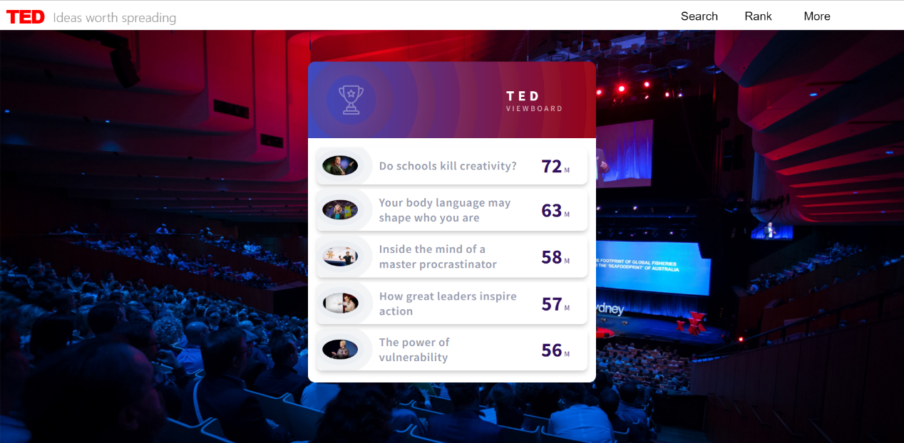

In the More page, we exhibit the results of visualization. Users will be provided with bar charts for the most popular tags and the most popular videos. What’s more, the web of inner relationship of different tags is also shown, which is completely magnificent.

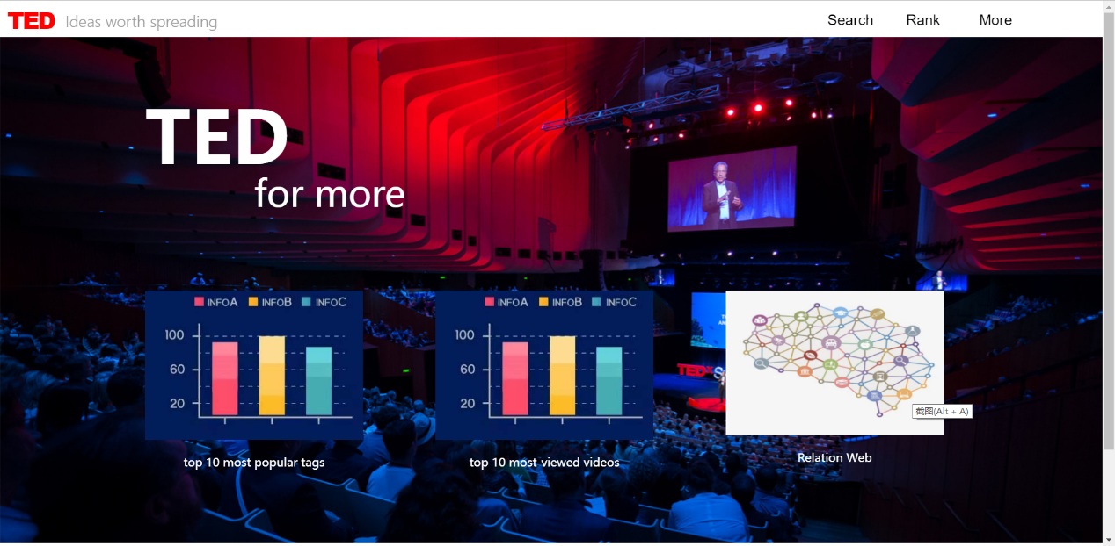

Besides those basic functions, some details are added to optimize the users’ experience. A head is added to every page as a navigation to other pages. Users can click the red TED to go back to the front page, search to the search page, rank to the rank page and more to the more page. And details hover and duration are also added to the result page, which makes it more convenient for users to gain a brief knowledge of the video they are going to watch.

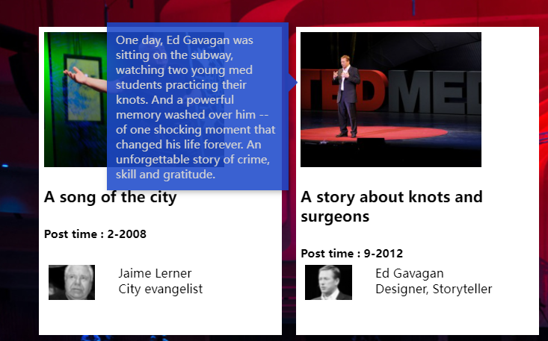

**Implementation**

Front page:

The background picture jumps into views eyes first. Then the title and the slogan slowly emerge, to impress our viewers. Next, the three button come out one by one. To realize this, we set the fade-in action in css.

For example, here is the one set in title.

Html:

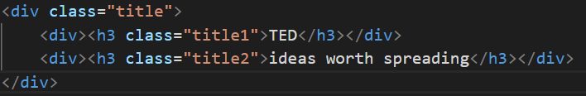

Css:

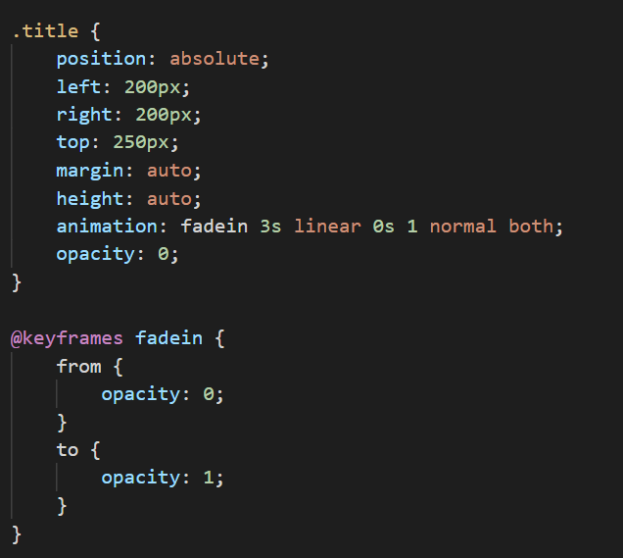

Beside, when your cursor is hovering over the three button, an arrow will appear in the right side of the button. This action is also set in the css file.

Html:

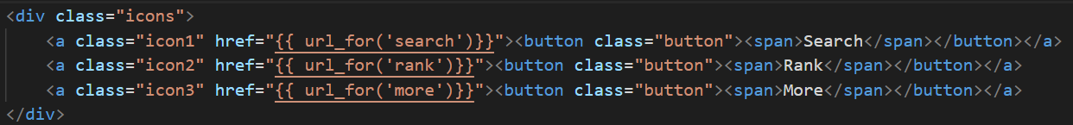

Css:

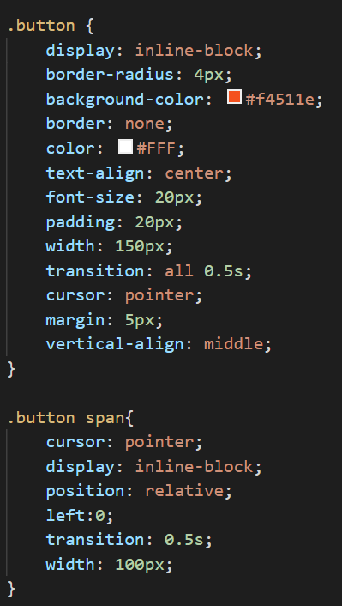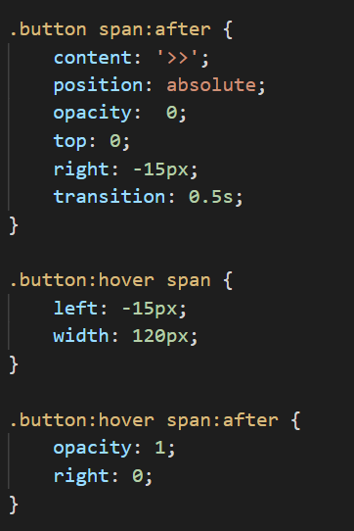

Search page:

When making the search page, a form should first be built. The search box for different search keywords should be provided.

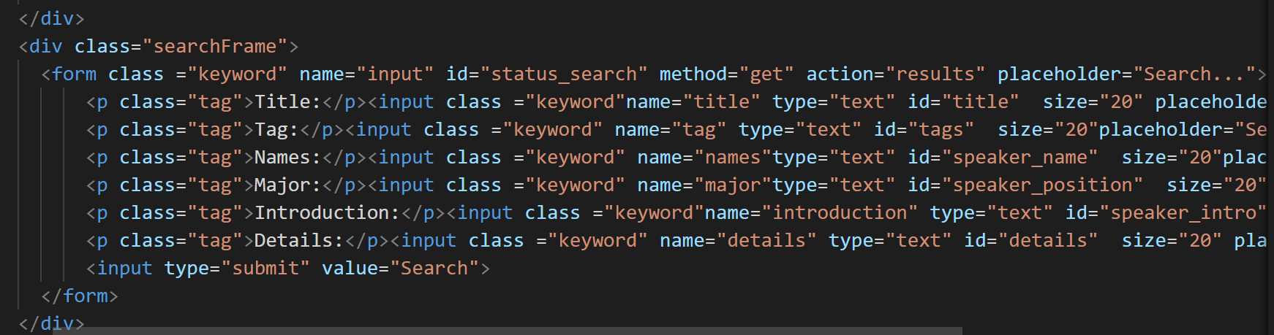

After the frame being settled, then it comes to the parameter transmitting between the search engine and the search page, and the outcome of search engine to the result page. In details, after users input the keywords for search ,the search page pass the input to the search engine, then the search engine pass the outcome to the result page. To make use of the search engine, it should be imported to the main file. At the same time, to build connection between the result page and the search engine, the outcome of the search engine should be changed to fit the result page. These are realized by the codes shown below.

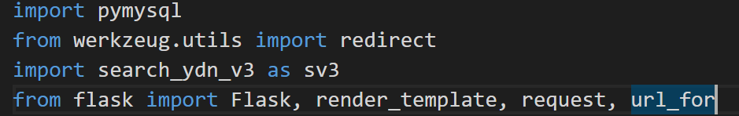

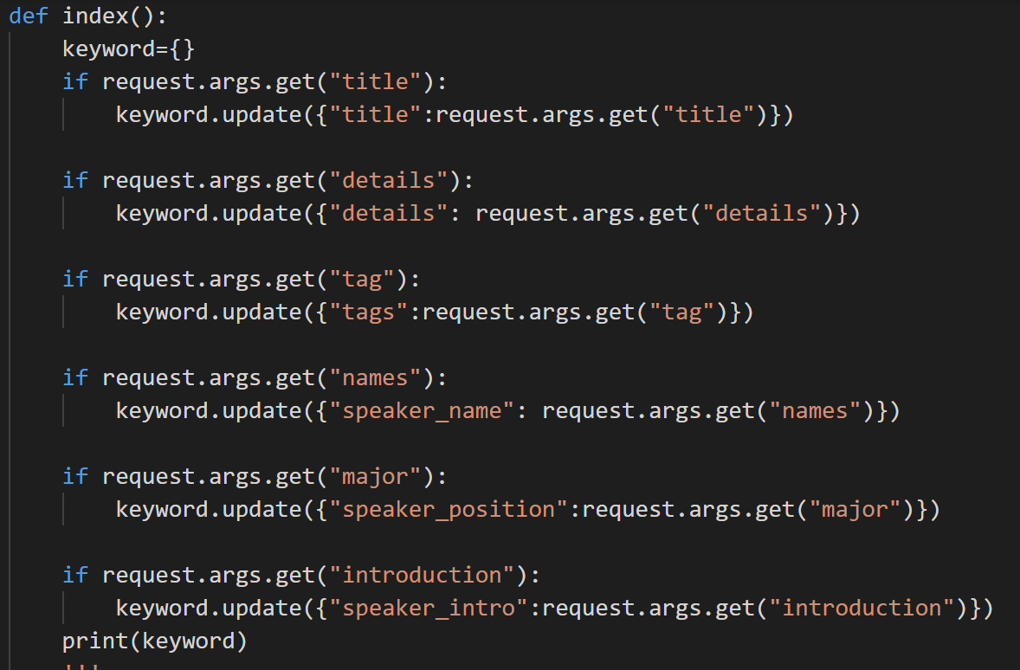

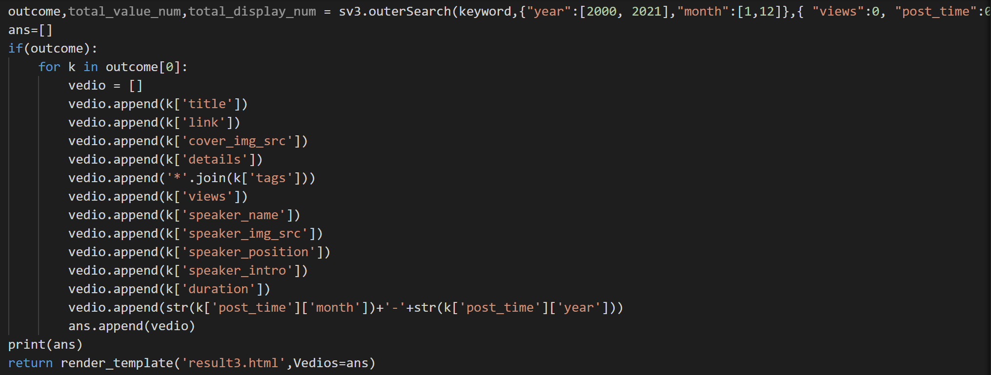

Result page:

Then comes the result page. The main function of the result page is showcasing all the results.

Therefore, we use a loop to realize this. Each of the searching results includes two parts. The main information of the video and the main information of the author. When the viewers click the cover of the video or the title of the video, they will enter the website of the original TED website to watch the video. Besides, when the cursor is hovering over the picture, the summery of the video will appear.

Besides, we add the function of turning pages. The views can browse more result by click the button below. Every time, we only provide 20 searching results ranked in the order of relationship score. It is in favor of the page quickly responding, or too many pictures can not be loaded at the same time.

Rank page:

For the rank page, the most important thing is to make the page pleasing as well as eye-catching. So instead of simply giving the data of those most viewed videos. We only show the top5, so we can make full use of space to exhibit the details of the top5, in this way, users will also more conveniently grasp the reason why these videos are such attractive and be absorbed in those videos. And the frame is built with the codes shown below.(it shows the exhibition of one of the 5 videos as example. The css file is too complicated to be cut into picture form, the details can be seen in the addenda.

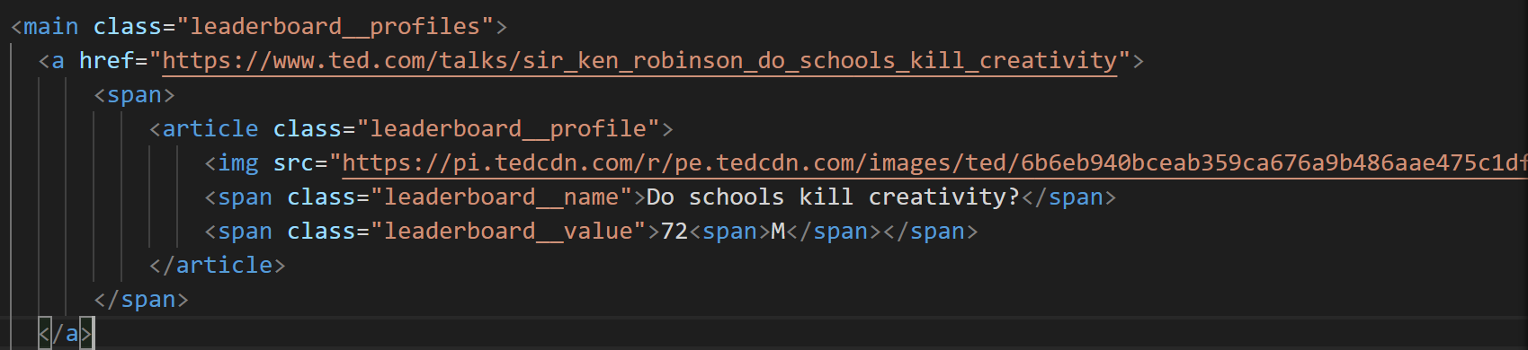

More page:

More page provides three images to click. You can know the top 10 most-viewed videos, top 10 most welcomed tags and the relationship between the tags.

## The difficulties

1.The first main difficulty is to find out where can we crawl down the information. We find that by directly sending request to the original URL, we could only get little information, far from what is demonstrated on the view of original website. It is natural that we thought those data were asynchronous loaded. However, though we carefully looked through the asynchronous requests sent by the website, we cannot find any response containing those data. So how can those data be loaded? By searching for the key words of information and checking one by one, we finally found that the data is not loaded by sending requests to certain URL, but is written to the page directly by a JavaScript function in the HTML text of the original website. And right in the body of the function, we find all the information we want. By extracting the information part of the function and transforming it into JSON form, we finally get the information.

Part of the script containing key information

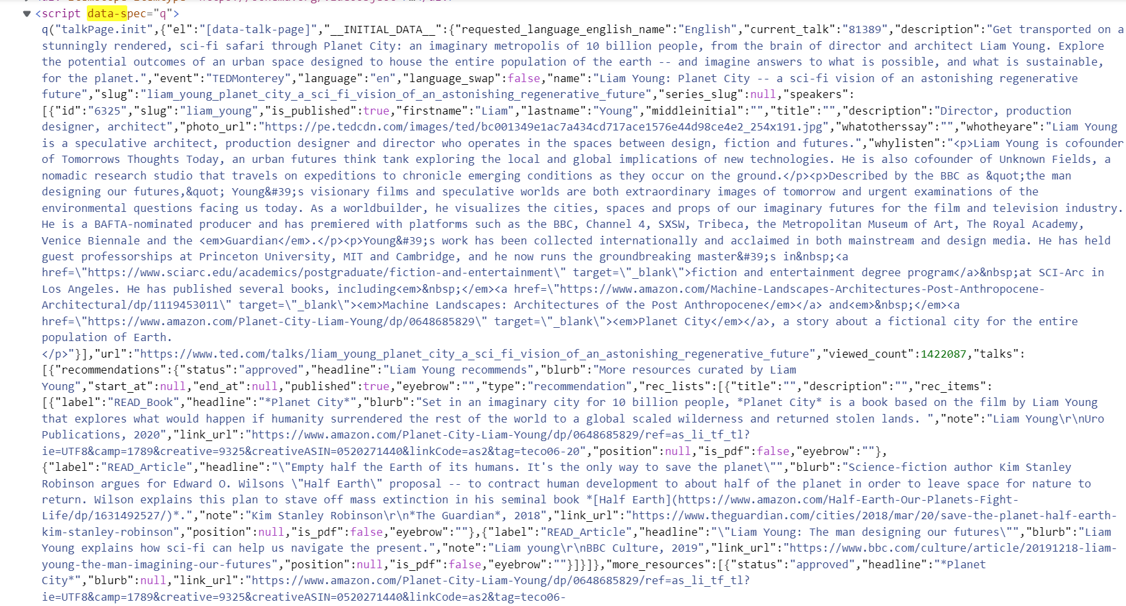

2.The second difficulty is that the amount of data is too huge and the crawler program runs too slow.

As the web server of TED is located abroad, sending requests is much slower than crawling domestic websites, let alone the huge amounts of data we needed. The network connection is so unstable that it constantly goes off-line. Also, the exceptions occasionally occurred may destroyed the whole crawling process, which is very depressing. As we finished the process of crawler and database operations before the thread pool was provided, we must deal with the problem by ourselves. Finally we decided to separate the crawling process into 4 parts, add lots of exception handling statement, or "try-except-finally" to ensure the stability, at a slight loss of efficiency. What’s more, we write the collected data into the text file right after one page of videos, which is 36, are crawled. Then the dictionary containing data is cleared. This helps a lot in minimizing the running memory.

3.Another difficulty we encountered was how to create an appropriate mapping to efficiently store and search the information. Furthermore, we wanted to implement a Multi-term and Multi-field Supporting Search Engine.

By using ‘Boolean Query’, we implemented the searching function that supported complex logic. Users can input keywords in their corresponding fields, and select different sorting methods. For each query, it returns entries matching keywords in every field accordingly, and is sorted by their relevance scores.

In addition, we have defined the tag field as keyword type, which means it only allows exact search. It’s infeasible when we want to search for more than one tags.

We need to use Terms Query. It returns documents that contain **one or more exact terms** in a provided field. The terms query is the same as the term query, except you can search for multiple values.

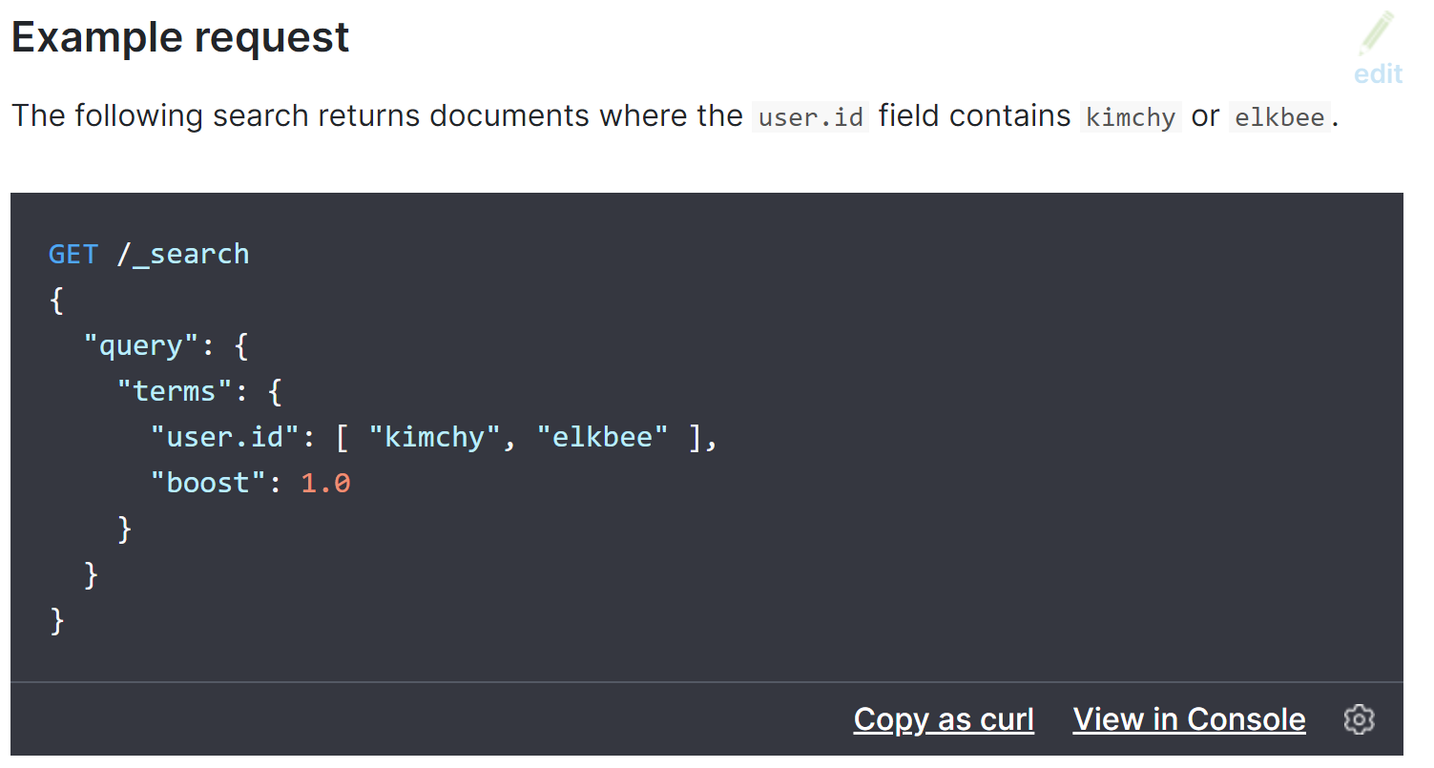

For instance,



Is the result of the input below:

keyword={"tags": "poetry performance painting"}

search_sort={ "views":0, "post_time":0}

search_range={"year":[2010, 2010],"month":[10,10]}

4.The parameter transmit between the outcome and the result page

To make the form of outcome and the parameter the result page can receive perfectly fit, the form of outcome should be shown. So a print function is added in the search engine file. However, we surprisingly find the form of outcome is shown in the nest of dictionary, while the result page can only receive parameter in the form of simple tuple or simple dictionary. So containers k and vedios are used to draw the necessary data from the outcome.

5.The parameter transmit between the search input and the search engine.

Since our search function is initially designed to do parallel search, so the relationship between each input keyword is OR. At first, we simply transmit the input to the search engine while ignoring the inner relationship, as some keyword search box might be empty, we failed to gain access to the result. After we check the url, we regretfully realize that we should write the keyword getting function with judging sentences, so that the condition of transmitting empty parameter illegally can be avoided.

6.The beautification of website page

Because the website page frame is our original work. To make the page pleasing to users’ eyes, we devoted a lot of time in the shakedown test, from details as small as the color, the border and the position of hover to the basic style of our website. It really calls for huge patience.

## shortages and prospects

Which can be further down to our website page is to add more detail function such as different sorting and ranking ways, tags which can be chosen when doing searching, as well as how to make visualization more closely matched with the whole system of our website. If time permits, we also want to add some more interesting functions to the web. For example, random recommendation to guess what the viewers like. What’s more, maybe the website can make full use of the script of the view. That remains to be developed.

## conclusion

In general, the program which including the function realization as well as the exhibition live up to my expectation. In the project, we have learnt a lot from practice. When we encountered some problems, we turned to teammates, classmates, teaching assistants and teachers for help; we learnt to take advantage of the website to take others successful experience for reference. We learnt to be flexible and do not back ourself into a corner. We had to discard some interesting ideas and compromise with reality. Also, the project enlightens us to think more from the users’ perspective, not only from my own, so as to design practical, functional and handy software for users.

More than anything, we gain a closer relationship. Working with group members broaden my horizons in cooperation, we have learnt a lot from the work division, such as how to give every member full play to their strong points, and how to communicate with members when having interfaces with other modules I am not that familiar with.

And finally, we would like to thank everyone who helped us for their generosity of support.